5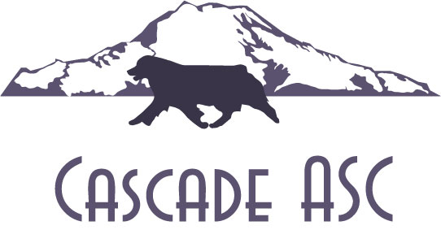
Cascade Australian Shepherd Club
Mothers Day Shows
May 8th & 9th, 2021
Port of Kalama Marine Park, 246 Hendrickson Drive, Kalama WA
For information call Crystal Ray 503-840-7372, email crystalgenes@hotmail.com
Conformation Entries: AUSTRALIAN SHEPHERDS ONLY Jr Entries: All Breed

click here for ASCA entry form
All ASCA and Cowlitz County Covid restrictions will be enforced. Exhibitors and spectators will be limited to owners, handlers, show committee and judges.
Show Secretary  Saturday AM: Crystal Ray  Saturday PM: Crystal Ray  Sunday AM: Crystal Ray  Sunday PM: Crystal Ray | Conformation Judge  AKC Judge: Rosemary Leist  AKC Judge: Dee Robison  AKC Judge: Betty Winthers  AKC Judge: Claire Mancha
FEES:
Conformation Pre-entry $17.00 / $19.00 day of
Jr. Handling Pre-entry $ 5.00/ $ 5.00 day of
Non-Reg. Pre-entry $ 12.00/ $14.00 day of
Pre-entry deadline Postmarked by: Mon. May 3rd, 2021
Mail to: CASC- Crystal Ray - PO Box 2396, Vancouver, WA 98668
Classes Offered: in order listed
Jr. Handling -All Regular Classes (inc. Pee-Wee 3-5 & Sub- Junior 6-7)
Non-Regular-Puppies 2-4, 4-6, divided by sex Veterans 7-9, 9-12, 13+
Regular Conformation - Starting with Altered 6-9, 9-12, 12-15, 15-18, Novice, Am Bred, Bred By Exhibitor, Open Blue Merle, Open Red Merle, Open Black and Open Red
Rosettes and Awards to: BJH, RJH, BOBP, BOSP, BOBV, BOSV, AWD, ARWD, AWB, ARWB, ABOW, ABOS, ABOB,WD, RWD, WB, RWB, BOW, BOS, BOB
Participant ribbons and awards to all Pee Wee and Sub Jrs., Flats 1st-4th place all classes.

ENTRIES:
Saturday AM: Conformation Entries........8:00-8:45am Judging at 9:00am
Saturday PM: Conformation Entries……11:00-11:45am Judging at 12:00pm
Sunday AM: Conformation Entries...........8:00-8:45am Judging at 9:00am
Sunday PM: Conformation Entries...........11:00-11:45pm Judging at 12:00pm
All PM shows to start at posted times or 1/2hr after the completion of AM judging
All current ASCA rules and regulations apply. All dogs 6 months of age & up must have individual reg. to compete in all ASCA sanctioned events. Jr. Handlers must enter all required information. ASCA Altered Conformation Program is open to all purebred, ASCA reg. Australian Shepherds over the age of 6 months that are either spayed or neutered. Dogs with LEP numbers are not eligible to compete in Altered Conformation. Dogs that have been altered may transfer points earned in the regular ASCA conformation program. ASCA Champions of record that have been altered may also compete in BOB competition. All entries must be on the new official ASCA entry forms with the agreement/disclaimer & signature on back. Incorrect and or missing information will invalidate entries. No entry shall be accepted from a dog or handler disqualified from the ASCA Conformation program; a dog or handler disqualified from all ASCA programs; or a person not in good standing with ASCA.
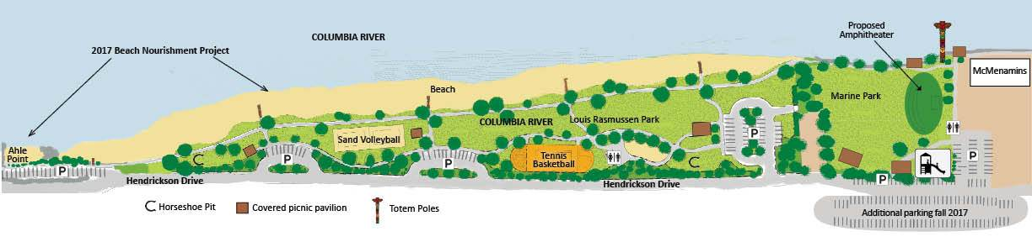

Directions from South on I-5: take exit 27 go left under the overpass follow signs to Port of Kalama, turn right on Toteff Rd then on Hendrickson Dr. Follow this until you reach Port of Kalama Marine Park, it will be on your left.
Directions from North on I-5 take exit 30 follow signs to Port of Kalama, this will put you on Hendrickson Dr. Follow this until you reach the Port of Kalama Marine Park, it will be on your right.
These shows are held outdoors on grass, Set up may begin at 8:30 AM Saturday & Sunday, all exhibitors and club members must be off premises by sundown on Sun. night. No overnight camping is allowed and no RV hook up or amenities. There are no electrical outlets near the pavilion, No Grooming in pavilion, this is a public park pavilion may be shared with other park goers. Bathrooms open at 8:00am Sat and 9:00am Sun. There are alternate bathrooms on either end of the Port of Kalama that are open earlier. You may leave your set ups up overnight at your own risk. The sprinkling system is on every other night so don't leave anything you can't get wet, Cascade ASC or Port of Kalama will not be responsible for any missing or lost items. All dogs must be on a leash or confined to a crate at all times except while in the performance ring during competition. Dogs must be on leash to and from parking area to show ring / grooming area. Dogs that are on a grooming table or in an uncovered X-pen must be attended at all times. All dogs must be current on Rabies Vaccinations and proof must be available for inspection by the show committee. Any owners not in compliance with these regulations will be asked to leave the grounds. No refund of any event fees will be given.
Veterinarian located in Longview Wa, Contact Lower Columbia Veterinary Clinic Address:940 14th Avenue, Longview, WA 98632 Phone: (360) 636-1801, email: lcvcpetdentist@yahoo.com
or Woodland Veterinary Hospital - 236 Davidson Ave, Woodland, WA 98674 Phone:(360) 225-9469
Motels that accept well behaved dogs (all require a deposit)
OYO Hotel Kalama  602 NW Frontage Rd  Kalama, WA  (360) 799-4976 | Guest House Inn,  Kelso, WA  800-214-8378 | Best Western,  250 Kelso Dr  Kelso, WA  800-764-7378 | Super 8 Motel  Kelso, WA  800-800-8000
Camping near by | Cedar’s RV Park  Kelso, WA  360-274-5136 | Brookhollow RV Park  Kelso, WA  800-867-0453 | Camp Kalama  Kalama, WA  800-750-5136
CASC Point Schedule 2019/20
Intact Dogs & Bitches: Schedule #2
3 dogs 1 point
6 dogs 2 points
11 dogs 3 points
14 dogs 4 points
17 dogs 5 points

Altered Dogs & Bitches: Schedule #1
2 dogs 1 point
4 dogs 2 points
8 dogs 3 points
12 dogs 4 points
14 dogs 5 points

