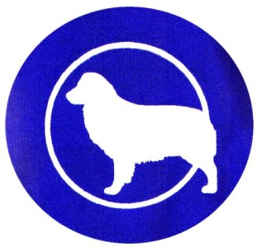
Cascade Australian Shepherd Club All-Breed/Mixed Breed Obedience Trial

(Sanctioning Pending)


March 14, 2015

Dog Days NW

7206 NE 37th Ave, Vancouver, WA 98665
Indoor Facility,
air conditioned/heated, fully matted

TRIAL START TIME: 10:00AM (Day of show entries accepted 9:00 am - 9:45 am)

Show secretary: Wendy Waggoner (360) 727-3188 or wendywagg@comcast.net
Rules & Forms can be found at http://www.asca.org/formsandrulebooks#obforms and also at the end of this premium.
*Pre-entry forms/payments MUST be postmarked by Saturday, March 7, 2015

Mail completed forms to: Wendy Waggoner, 20804 NE 40th Ave, Ridgefield, WA 98642

JUDGE: Hilary Hines
Obedience Trial Entry Fees (each trial):

*Pre-Entry (non-refundable): **Reg: $15.00; Jr’s: $3.00

Day-of-Show (refundable at Show Secretary’s discretion): Reg: $18.00; Jr's: $3.00
(**Entrants competing with the same dog in Utility & Open in the same trial pay $5 LESS for the 2nd entry)
Please Use Only One Entry Form per Dog
Make all checks payable to Cascade ASC

CLASS RUN ORDER:

- Utility B, Utility A

- Open B (ODX/CDX), Open A (ODX/CDX), Open long sits and downs (Open B & A may be combined).

- Novice B, Novice A, Novice long sits and downs (Novice B & A may be combined)

- Beginner Novice B, Beginner Novice A (Optional Titling Class)

1st thru 4th place and green qualifying ribbons will be awarded. Rosettes will be given for HIT, High Combined, HIT Aussie, HIT Other Breed, HIT Junior Handler. Dogs must receive a qualifying score to receive a ribbon.

ASCA® Performance Titles. A Tracking number is required for obedience competition. Rules and forms can be found at http://www.asca.org/formsandrulebooks. Forms are also included at the end of this premium. A dog will be allowed to be shown at the trial where the handler applies for an ASCA® tracking number. No dog without an ASCA® individual registration, LEP number or ASCA® tracking number may compete in any ASCA® Obedience Trial.

ASCA® OBEDIENCE IS OPEN TO ALL BREEDS (INCLUDING MIXED BREEDS)

Event Information
Entry form is included at the end of this premium. Forms also can be found at http://www.asca.org/formsandrulebooks. Here are links to specific forms:
Service membership/tracking = http://www.asca.org/Portals/0/trackapp.pdf
Conformation & Obedience = http://www.asca.org/Portals/0/obedwtxentry.pdf

ATTENTION EXHIBITORS
These shows will be judged and run by the Show Rules of the Australian Shepherd Club of America. All dogs, six months and older, must have an ASCA Registration Number or ASCA Tracking Number (for Obedience and Rally) in order to compete in ANY venue (please have a copy of this number available at the show). Dogs must be ready for judging.
Neither the club nor the chairman will be responsible or obligated to furnish any services for notifying exhibitors or their agents of class judging. Entry fees will not be refunded in the event a dog is absent, disqualified, excused, or barred from competition by action of the show committee. Entry fees will only be refunded if the refund request is received before the pre-entry closing date, no entry fee will be refunded if the show cannot be opened or completed by reasons of riots, civil disturbances, fire, Acts of God, or public emergency. The show-giving club, the Show Chairmen, their agents, officers, and/or committee shall assume no responsibility for injury to children. Judges may be substituted. All dogs must be leashed or crated at all times, except when competing. No electrical and/or mechanical training devices will be permitted on the show grounds. Please clean up after your dogs. No bitches in season in the building! For the safety of your dogs and others all dogs must have current vaccinations against rabies, you are asked to bring a copy of the rabies certificate with you.
Handler is responsible for his dog and must keep the dog under his control at all times. Dogs must be on leash when not in the ring. Handler will be responsible for any injury caused by their actions or that of their dog.
Refunds given up to close of pre-entry deadline. Substitutions allowed with dogs that you own or co-own.

WE NEED YOUR HELP! ANY AND ALL HELP IS GREATLY APPRECIATED!!!!
Our club is small and we need much help. If you can steward, set up or help with other tasks, we would greatly appreciate it! Please contact Wendy Waggoner at (360) 727-3188 if you can help.

ACCOMMODATIONS:

Hotels which accept dogs:

Quality Inn and Suites (I-5 exit 4, east 1 block to HWY 99, right, 7 blocks south)
7001 NE Hwy 99
Vancouver, WA 98665
(360) 696-0516

Shilo Inn - Hazel Dell/Vancouver
13206 Highway 99
Vancouver, Washington 98686-2795
Hotel: (360) 573-0511
Reservations: (800) 222-2244

Best Western Ferryman Inn
7901 NE 6th Ave.
Vancouver, WA 98665
(360)574-2151

RV Parks:

RV Park Vancouver

99 RV Park

EMERGENCY VETERINARIAN
Columbia River Veterinary Specialists
6607 NE 84th St #109, Vancouver, WA 98665
(360) 694-3007
Click here for map & directions to CRVS

Directions to Dog Days NW:

7206 NE 37th Ave, Vancouver, WA 98665 Dog Days NW

From I-5, take the NE 78th St. exit #4 and turn east off the exit. Drive 1.8 miles eastward on NE 78th St. and turn right (south) onto St. John's. Drive about a half mile and watch on your right (west) for the Shur-Way Building Center. Just after the Shur-Way, turn right onto NE 37th Ave. Turn left into the fenced parking lot and we are the second (last) building.

From I-205, take the Padden Parkway West exit #32. Drive 1.5 miles westward on NE Padden Parkway which becomes NE 78th St. Turn left (south) onto St. John's. Drive about a half mile and watch on your right (west) for the Shur-Way Building Center. Just after the Shur-Way, turn right onto NE 37th Ave. Watch on your left for the first fenced parking lot and we are the second (last) building.

Cascade ASC Club Officers:

President Donna Burdick diamondhillaussies@gmail.com
Affiliate Rep Jamie Hansen jhansen@gmail.com
Vice President Nancy Jackson njackson@petponderosa.com
Secretary Kathy Remington kremington245@yahoo.com
Treasurer Crystal Ray crystalgenes@hotmail.com
Board Member A Large Lisa Nicholson angeldewcrew@comcast.net
Show Coordinator Lisa Nicholson angeldewcrew@comcast.net
Show Coordinator Crystal Ray crystalgenes@hotmail.com

Membership Chair Jen Petlig rebelrunner@comcast.net
Membership Committee Kathy Remmington aussieszazu@hotmail.com
Membership Committee Lisa Nicholson angeldewcrew@comcast.net

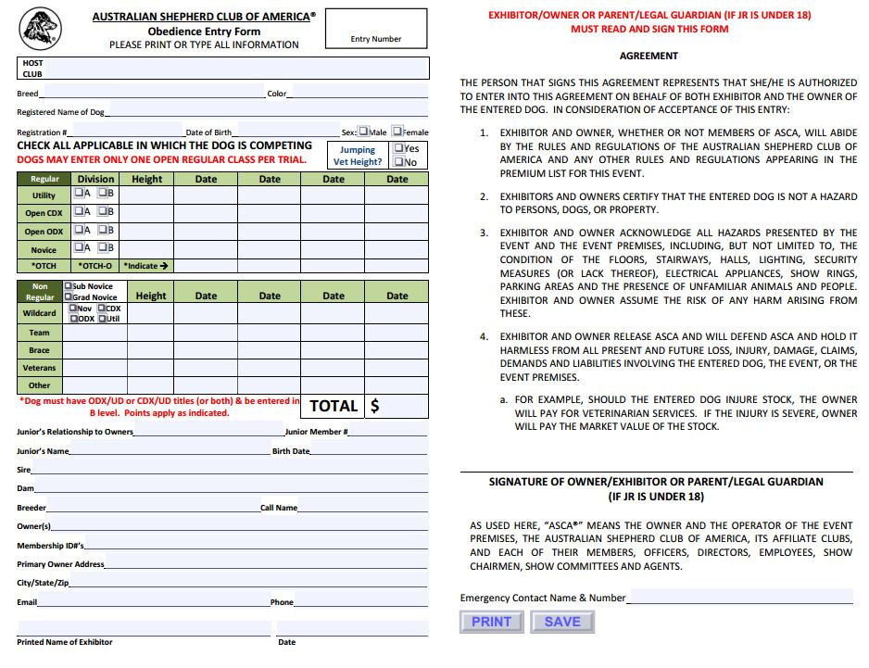

In order to have ASCA® trial points tracked and to receive ASCA® titling certificates, each non‐ ASCA® registered dog will be required to have an ASCA® Tracking Number. This is a one‐time fee of $10/dog. At the time of applying for the tracking number, the individual owner must also be an ASCA® member (minimum membership type of “Service” is required). ASCA® membership does not need to be maintained in subsequent years. It will be the responsibility of the owner to identify previous ASCA® points earned when applying for a Tracking Number.
®
ASCA® Service Membership and Tracking Number Application
Please type or print clearly. Incomplete or illegible forms will be returned. Membership Application:
Owner’s Name (1): Owner’s Name (2): Owner’s Address: City: State: Zip: Phone: Email:
Service Membership Fee: $10.00 per person
(If you are interested in other membership types, please see our website, www.asca.org)
I (We) agree to abide by the ASCA® Articles of Incorporation, Bylaws, and all ASCA® Rules and Regulations governing the ASCA® Registry and all other ASCA® programs.
Owner’s Signature (1): Owner’s Signature (2): If Owner/Co‐Owner is 17 or under, please provide date of birth:
Dog Information:
Lifetime fee for tracking number is $10.00 per dog for ASCA® Members
Dog’s Full Name: Dog’s Call Name: Sex: M F Birth date: Breed: Previous ASCA points earned (If more space is needed, please attach another sheet):

➢FREQUENTLY ASKED QUESTIONS

Do I have to have a tracking number to compete?
No, you do not need a tracking number in order to compete in Agility or Stock.
You will need a tracking number to enter an Obedience trial or Tracking Test.
Your dog does not have to be a purebred to receive a tracking number from ASCA®.
Why would I need or want a tracking number for my dog?
If you would like to have your dog’s points and titles recorded by ASCA®, and if you’d like to receive title certificates in the mail for your accomplishments, you might want to obtain a tracking number.
How much is the total cost for a tracking number?
In order to obtain a tracking number for your dog, you must be at least a “Service” member. The cost for Service Membership is
$10.
- Your membership is good for one year; however, it does not need to be maintained in subsequent years, unless you want to obtain another tracking number for another dog after your membership has expired.
This membership fee is in addition to the tracking fee of $10 per dog. A tracking number is good for the lifetime of the dog. If you only have one dog, the total cost would be $20. For two dogs, the cost would be $30, etc.

PLEASE THIS SPACE TO PAY WITH A CREDIT CARD
CC#
EXP
CARDHOLDER

Mail completed form with check, money order, or credit card information to: ASCA® Business Office
6091 E State Hwy 21 Bryan, TX 77801 Phone: (979) 778‐1082
You may fax the form to us at: (979) 778‐1898

Revised 5/24/11

